ca
CMUG
CCI

Report of CMUG Integration Meeting 9
  - Barcelona Supercomputing Center, Barcelona, 6-7th November 2019

Accepted by: | Institute / project | Signature
Richard Jones | Met Office / CMUG
 | ESA / CMUG

Version 2 10th August 2020

Lead Authors: Kate Salmon, Paul van der Linden & Richard Jones, Met Office
Contributors: CMUG partners, CCI ECV teams, ESA

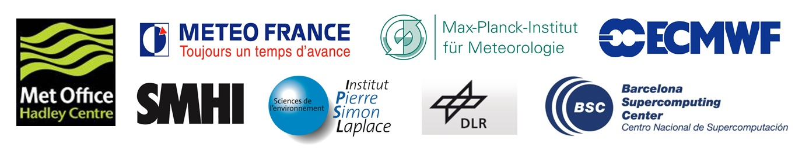

Table of Contents
1. Introduction 3
2. Aims of the meeting 3
3. Presentations 4
3.1 Meeting aims and Keynote presentation 4
3.2 CMUG results to date 4
3.3 Project results and Initiatives relevant to CCI 5
3.4 Climate Services and data 6
4. Actions, Agreements and Issues 7
5. Climate Science Working Group Session 8
5.1 ECV interactions exercise 8
5.2. Breakout discussion groups 9
5. Output from Science Leads Session 14
Annex 1: Programme 16
Annex 2: Presentations 18
Annex 3: Registered Attendees 19
Annex 4: Feedback from Integration Meeting 21

1. Introduction
This was the ninth Integration Meeting organised by the Climate Modelling User Group (CMUG) of ESA’s Climate Change Initiative (CCI). It was the second Integration Meeting of the CCI+ phase which saw nine new ECVs added to the initiative. The programme for the meeting was co-developed by CMUG and ESA with input from the Science Leads and CSWG members of the CCI ECV projects.
The meeting was attended by Science Leads and Climate Researchers from all CCI projects, as well as several ESA Technical Officers and experts from other relevant ESA projects (CCI Data Projects, C3S). Some CMUG partners attended in person as did several ESA Technical Officers, and some external experts who gave presentations relevant to promoting and supporting interactions and discussions. There were 71 attendees in total over the two days of the meeting. The local organiser was the Barcelona Supercomputing Centre and the venue was the Universitat Politecnica de Catalunya.
The programme, link to presentations and attendee list are given in the Annexes to this report.

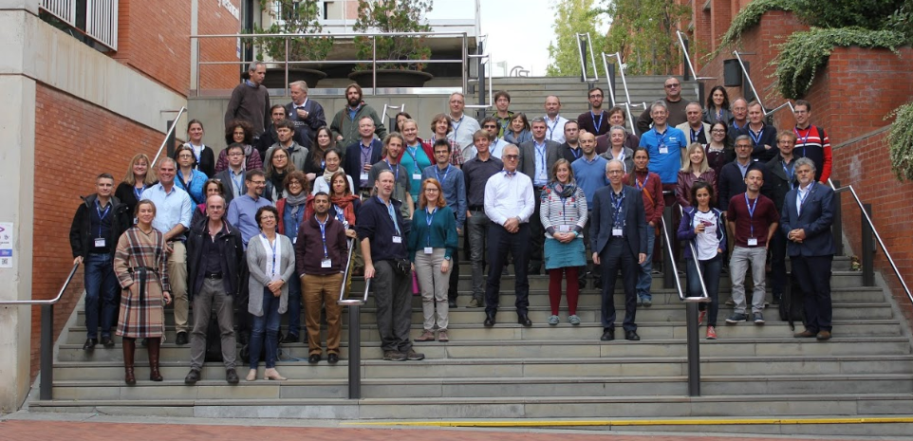
Picture: some of the meeting participants during a break between sessions.

2. Aims of the meeting
The aims of the meeting were agreed with ESA in advance and were broadly similar to previous CMUG Integration Meetings. Day 1 of the meeting consisted of plenary talks reporting back on CMUG results for discussion, with the results of CCI experiments presented in the poster session. The Climate Science Working Group (CSWG) and Science Leads (SL) then met separately for individual discussion sessions which had their own aims and objectives described later. Day 2 involved further discussions within the CSWG and SL groups and a further plenary session which described the work and results of climate research projects and initiatives relevant to the CCI (such as EUMETNET, Future Earth, AIMES, FIDUCEO and GEWEX G-VAP). The afternoon focussed on reporting of climate service related activities relevant to planned CCI data outputs. The broader aims of the meeting are listed below:

1. Presentation and discussion of CMUG results
2. Discussion of ECV User Requirements (with respect to the needs of the Climate Research Community, CMUG and GCOS requirements)
3. Discuss the emerging product specifications for the new ECVs
4. Examine how projects are addressing an integrated perspective for consistency between ECVs
5. Discuss how to deal with uncertainties in products (how to capture and describe them for users)
6. Develop ECV projects' data needs for ECMWF reanalysis data
7. Allow CMUG and the existing ECV teams to demonstrate 'best practice' to the new ECV teams
8. Maintain oversight of the position within the international framework in which CMUG/CCI is operating

3. Presentations
The following section summarises the discussions following the Plenary presentations.

Wednesday 6th November

3.1 Meeting aims and Keynote presentation
Meeting Aims (Richard Jones, Met Office, CMUG Lead Scientist)
It was agreed that good planning around the timing of including CCI datasets into the CMIP6 archive is needed, and this should start soon. Good supporting documentation is also needed for CMIP and the products need to mature further for this to be achieved. Richard emphasised that CMUG goes beyond climate modelling and also collects climate information to be shared with CCI projects.
Keynote: GCOS ECVs - background plans and development (Caterina Tassone, GCOS / WMO)
An update on GCOS plans and requirements was welcomed by all, especially the news of when and how the GCOS requirements and implementation plan would be updated. Discussion focussed on interactions for public reviews through a platform (adapted from the WMO). It is important to get users more involved to identify the real needs independently of the technology used for the observational data (sounding balloons, satellite, planes), to avoid being biased to a specific technology.

3.2 CMUG results to date
User requirements (Richard Jones in lieu of Paul Van Der Linden)
There was a lot of interest in the outcomes of the CMUG user requirement survey with highlights of the CMUG D1.1 User Requirement Report presented. The full report presents results per ECV, but there was not time to go through all 23 in this presentation. There were further questions on who the survey had been circulated to, and the answer is all possible users of climate data i.e. technical users, modellers, researchers and climate service users. Other CCI projects have also conducted surveys (from different perspectives) and wondered how the results from each could be combined. The CCI ECV teams expressed a strong interest in seeing the final report and knowing more about CMUG’s activities to maximise the results of user requirement assessments.
Documentation Assessment (Kate Salmon)
There was some discussion about creating a template for the design of the documentation for each ECV as the information is difficult to find (all documentations are currently written differently). There was support for this but Chris Merchant pointed out that the old ECVs have already written their documentation so there would be no further work done on these. The CMUG report (D2.3) which assess Product Documentation has grouped its results thematically along “Quality”, “Maturity” and “Uncertainty”. There is still some merit in changing the layout of future versions of the CCI ECV product documents to better signpost relevant information for users.
Foresight Report (Richard Jones)
There was a lot of interest in this report and Richard will include all Science Leads when he circulates the next (near final) version after the meeting.
CMUG WP3 Quality Assessment (Jean-Christophe Calvert)
The main part of the discussion focussed on the desire of the CCI ECV teams to become more engaged with CMUG, including the task design stage to avoid duplication, prevent sub-optimal use of ECV data and maximise the relevant scientific output. This led to the idea that scientific studies should be co-designed by modellers.
CMUG WP5 The ESMVal Tool (Björn Brötz)
The main message from the presentation and discussion was that the latest versions of some of the ECV datasets are no longer produced within the CCI but are now produced by C3S. This means that data users should always contact CCI data producers before using a CCI ECV dataset (in case it has been migrated to C3S).
CMIP6: high-level feedback (ESMValTool) (Björn Brötz)
The Clouds CCI is an ECV already included in the ESMValTool to evaluate and diagnose CMIP6 simulations (e.g. model biases, seasonal cycle, PDFs). Other ECV datasets (e.g. water vapour) are also available in the tool but are not the CCI dataset. Some of the CCI's included in ESMValTool v1 will need to be re-included in ESMValTool v2.

3.3 Project results and Initiatives relevant to CCI
New WRCP Strategy (Francisco Doblas-Reyes, BSC)
The mission of the World Climate Research Programme (WCRP) is to coordinate and facilitate international climate research to develop, share and apply the climate knowledge that contributes to societal well-being (it does not produce research per se, it coordinates and facilitates it). CMUG can contribute to an Earth system approach but it only has a small budget (small amount of money given to observations which are being produced and current resources make this difficult). Greater user engagement and requirement gathering is needed; interfacing between different projects e.g. C3S, ESA, CCI and the ESGF etc. It is confusing for users to have different portals and interfaces (different data offerings). However, the ESMValTool offers a single entry point, and there needs to be more investment in this; perhaps from ESA CCI. WRCP is undergoing discussion on whether to restructure itself perhaps resembling other programmes such as GCOS, but this may be done more effectively after e.g. WMO has finished its own restructuring.

Thursday 7th November
EUMETNET Climate Activity (Melita Perčec Tadić, DHZ)
There was a suggestion from the audience to include the ERA4CS (a JPI project) Climate Services community in CCI results. It is a European programme featuring locally-based climate services involving climate scientists but also includes graduates from the arts and social sciences.
Future Earth and the AIMES project (Sophie Hebden, ESA Climate Office)
Sophie presented on the AIMES community. There was discussion as to how to best get involved in working with this group. Sophie identified herself as a representative who could foster collaboration between AIMES and CMUG / ESA. There was also an observation that a lot of energy is going in to what data has been lost, but perhaps more effort should go into what data can be restored.
FIDUCEO Project Outcomes (Chris Merchant, University of Reading)
Chris presented key results of this project which is concerned with producing fidelity in climate observation datasets. The discussion after the presentation was around the propagation of uncertainties. C3S should ensure that data providers aim for a proper definition of uncertainty to avoid the mis-propagation of it when users regrid their datasets. There was a good suggestion for the ESMValTool to build this in.
Presentation on G-VAP (Marc Schroder, DWD, G-VAP co-chair)
The G-VAP team haven’t yet evaluated all the different tools that they will use in their evaluation. They will evaluate forecasts using the historic data record, so use evaluation in the same way (in part) that CMUG, and users of the ESMValTool do. It would be good to connect the different ESMValTool user communities to see if there is an efficiency or synergy in bringing these user groups together.

3.4 Climate Services and data
C3S_512 EQC for the CDS (Carlo Lacagnina, BSC)
This presentation described the work and results of the Evaluation and Quality Control for climate datasets that are (or will be) deployed through the Copernicus Climate Data Store CDS). The project has been running for over two years and builds upon earlier research in this area. Inter-consistency between datasets, traceability of quality, user engagement, and quality metrics are all key areas for this service.
Introduction to C3S_511 QA of observational data (Chiara Cagnazzo, CNR)
This presentation was about the C3S service for the quality assurance of climate observations data and datasets, as provided in the CDS. It prompted discussion on whether a dataset is not fit for purpose, whether the CDS is able to flag this at source? For example, will a specific variable be flagged if it is unsuitable? The CDS can only provide recommendations e.g. when there are big biases. The CDS can flag where this is documented but it is ultimately the responsibility of the user to use the data appropriately based on the data quality flags provided. Each user will have their own unique definition of what is “fit for purpose” for them.
The C3S_511 QA of observational data, including CCI data (Björn Brötz, DLR)
Discussion was around version numbers, from which variables and datasets. Bjorn assured that when the work flow is ready, it will be passed on to data providers. With regards to the validation of the CCI dataset, there is no guarantee that data providers will be contacted.

CCI Data, (Alison Waterfall, CEDA and Ed Pechorro, ESA)
Mapping between the C3S ECV datasets and CCI ECV datasets is crucial (for areas such as updates, revisions, length, etc). Currently the Open Data Portal review this every 6 months. There was some discussion as to why 6 months was appropriate as it seems like a lot of work to get the data into the right format. However, it is just evaluated every 6 months in order to address any issues, not to make fundamental changes.
New CCI Knowledge Exchange project, (Stephen Plummer, ESA)
The key role of CCI KE is to ensure user engagement - each tool needs user input to make it work. Stephen encouraged discussion about what we would like to see from the website and from the toolbox (filling out the survey provided). He also mentioned a different form of communication e.g. through narrative/stories about what the CCI actually does.

4. Actions, Recommendations, Agreements and Issues
This section records the ‘items of note’, actions, agreements and issues arising from the meeting. Actions from the parallel breakout groups for Science Leads and CSWG are recorded in the respective sections of this report (4 and 5). The results of the post-meeting feedback form are given in Annex 4.

# | Type | Description | Owner
1 | Action | Ask for more targeted responses on the EO foresight report | Richard Jones
2 | Action | Filter the User Requirement Survey per ECV | Paul VDL
3 | Action | Some of the CCI's included in ESMValtool1 need to be re-included in ESMValTool2 | Björn Brötz
4 | Recommendation | Integration meetings could be held with other ESA meetings to reduce their carbon emissions | ESA / CMUG
5 | Note | ECV teams might need specific help and support in preparing data products for the CMIP archive | DLR
6 | Recommendation | There is merit in the new ECV teams producing technical documentation to a common format / template, but this would need to be organised | ESA
7 | Recommendation | ECV teams should be consulted in the design stage of future research studies by CMUG | CMUG
8 | Recommendation | Raise and maintain high levels of contact between the ECV teams and CMUG about each other’s activities and results | CMUG / ECV teams
9 | Note | The newest version of a CCI dataset might be served by the C3S CDS, not necessarily by the ECV teams | CMUG / ECV teams
10 | Recommendation | Consider including ERA4CS in future CCI outreach and engagement work, especially if they can feedback on their work using social sciences | ESA / CMUG
11 | Recommendation | Take action to realise the benefits to the CCI of increased communication and engagement with the AIMES community | ESA / CMUG / ECV teams
12 | Noted | It would be good for climate researchers if the ESMValTool had a module for analysing the propagation of uncertainty | DLR
13 | Action | Complete the KE user engagement survey | ECV teams / CMUG

5. Climate Science Working Group Session (CSWG)
This session was held in parallel to the Science Leads session over Wednesday afternoon and Thursday morning and allowed researchers of the CSWG (about 30) to work together. The overall aims of the CSWG session were as follows:
- To get to know each other (and each other’s work) and welcome the new ECVs (this was done using a team bingo exercise to encourage people to talk to one another).
- To identify common science research questions which could be answered together
- To identify common challenges that could be solved by working together
- To come up with some tangible outcomes as to how groups can continue interacting in the long-term.
As part of the session, Thomas Popp gave an overview of his consistency paper and Philip Eales provided a demonstration of the CCI Climate from Space iPad app.

5.1 ECV interactions exercise
Aim
The first exercise in the CSWG breakout group was designed to identify which parts of the climate system each of the CCI ECV projects is involved, so as to visualise the climate systems commonalities between different CCI ECV projects. This was then used in identifying common research questions/challenges shared by multiple CCI ECV projects.
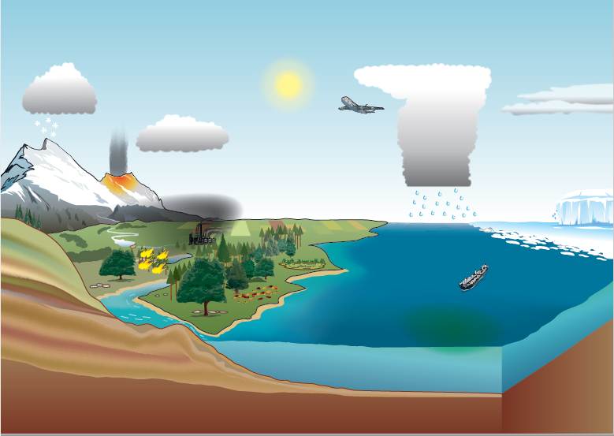
The participants answered the following question ‘how does your ECV contribute to the fundamental understanding of the climate system?’. Post-it notes coloured according to each component of the climate system (blue = ocean, green = land, yellow = cryosphere, red =atmosphere) were provided for participants to answer the question on, and to then add to the following climate schematic:
Figure 1. Climate schematic used to identify which fundamental parts of the climate system each CCI project/ECV contributes to.

Outcome
The outcome of the exercise showed that the following CCI ECV projects contributed to the following components/processes within the climate system. (Please note, this is not exhaustive as not all CCI projects/ECVs were represented at the meeting):

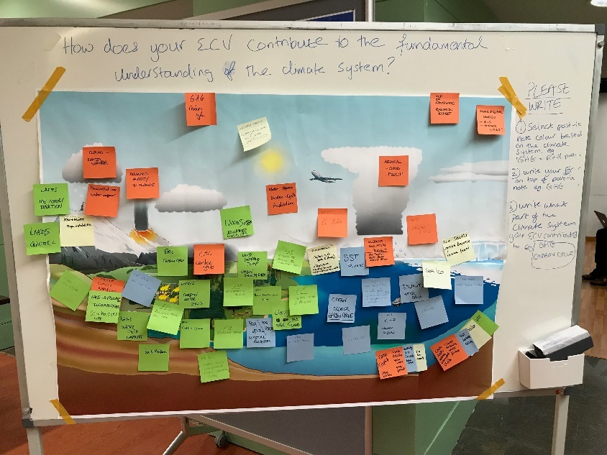

Figure 2. Climate system schematic visualisation of where each ECV contributes.

Carbon cycle: Lakes, Permafrost, GHG, Fire, Lakes, LST, Ocean colour, HRLC, Aerosols
Water cycle: Water Vapour, Salinity, Lakes, (Permafrost)
Land-atmosphere-ocean interactions: SSTs, Soil Moisture, LST, HRLC, Lakes, Sea State, SSS, Biomass, (Permafrost), Fire
Radiation budget: Water Vapour, Clouds, Lakes, Ozone
Ice sheets and permafrost: LST, Lakes, Ice sheets, Sea Level, Sea State, Permafrost, Glaciers

From this, it was clear to see that different CCI ECV projects contribute to multiple parts of the climate system and there was no obvious mechanism to group people based on this. Thus, for the breakout discussion groups, people were divided along climate system groupings (land, ocean, atmosphere, cryosphere).

5.2. Breakout discussion groups
Aim
The CSWG were split into three smaller groups (with land, ocean, atmosphere, cryosphere) split evenly. The objective of the breakout discussion groups was to answer the following questions:
- What research questions could be answered by working with other ECVs?
- When bringing together multiple datasets, what challenges do you face and how would you overcome these?
- Are the interactions between ECVs sufficient? Do they need to be improved and what tools could help communication and collaboration?
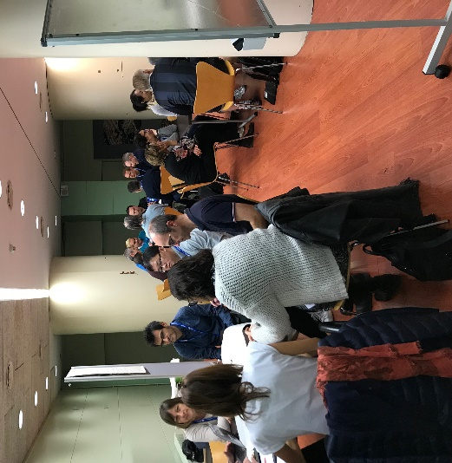

Figure 3. Break out discussion groups within the CSWG.

Outcome
- What research questions could be answered by working with other ECVs?

- Need to use ECVs together to improve parameterisations and uncertainty modelling.
- ECVs could be used to help constrain one another during retrieval e.g. SST could constrain water vapour.
- New ECVs should be designed to cross-cut earth processes e.g. surface radiation linking atmosphere, ocean and land or e.g. Understanding the diurnal cycle of soil moisture on LST e.g. Ocean driving processes- convection related to surface salinity, temp, currents (SSH), sea ice
- There are already a critical mass of satellite ECVs to tackle cycles/fluxes/processes; improving data assimilation could help with learning how well the processes are represented.

2. When bringing together multiple datasets, what challenges do you face and how would you overcome these?

Challenges | How to overcome
Temporal, spatial and technical consistency | - Issues considered in Thomas Popp’s paper  - Verification of scientific consistency using data assimilation  - Verification of scientific consistency using in-situ core validation sites
Data policy- it’s not always clear to the users what is allowed within policy | - All data should be open-access, with or without user registration
Mismatch between models and observations (parameters/resolution/timespan/uncertainty/data format are not the same). | - Simulators are present for some ECVs, but not for others.  - Continue to map modelled/observed ECVs (obs4MIPs), but need more observation operators, CDF-matching.  - More communication between ECVs (ECVs are technology dependent but need to be honest about this).

3. Are the interactions between ECVs sufficient? Do they need to be improved and what tools could help communication and collaboration?

Improvement in meetings and communications
- The number of interactions is sufficient (or could be more), but the nature of interactions could be made more efficient e.g.
  - More discussions, shorter updates (i.e. presentations)
  - Better way of communicating outside of prescribed meetings e.g. could use the co-location/EGU to have regular, more informal catch-ups. Co-location meetings could be a good opportunity to provide more regular updates rather than an annual Integration meeting.
- Consistent communication. Make sure all communication is based in one place and includes everyone i.e. either Slack OR Email/Google Drive/SharePoint.
- Before the Integration Meeting, send around abstracts of talks/posters to encourage more interactions at the meeting.

Strategic Improvements
- Currently, technical interactions between scientists work really well, but there is a gap between CMUG and scientists.
- Currently, the scientific interactions are driven by CMUG without enough input from scientists (e.g. CMUG’s focus is biased towards specific ECVs). Scientific interactions need to be driven by scientific questions co-created by science leads, scientists, climate modellers and CMUG together. In order to do this, we could:
  - Identify some key scientific themes/problems e.g. from the WCRP Grand Challenges which could be solved by bringing together different ECVs/CCI projects for discussion.
  - Improve interactions between CMUG/CCI projects e.g. through speed-dating these common themes.
  - Both of these ideas would need co-investment from all parties involved and could come under the remit of ESA for the next Integration Meeting.

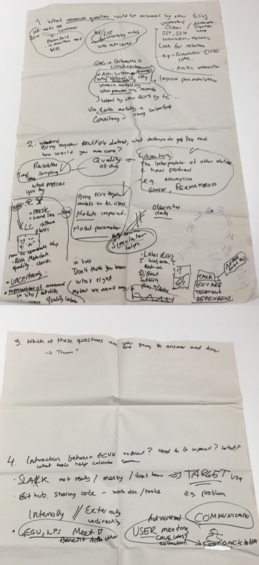
Figure 4. Group 1 discussion notes
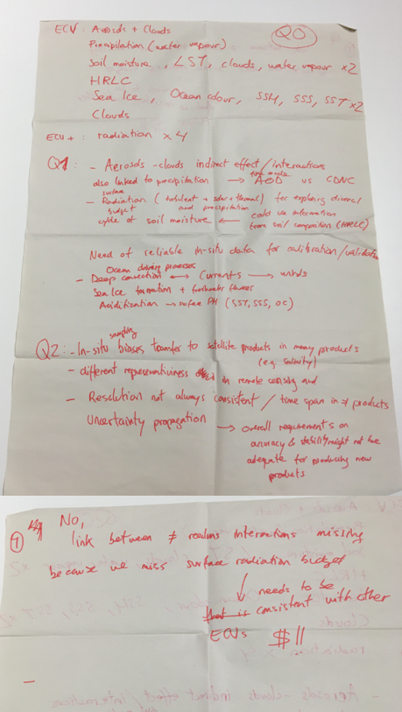

Figure 5. Group 2 discussion notes.
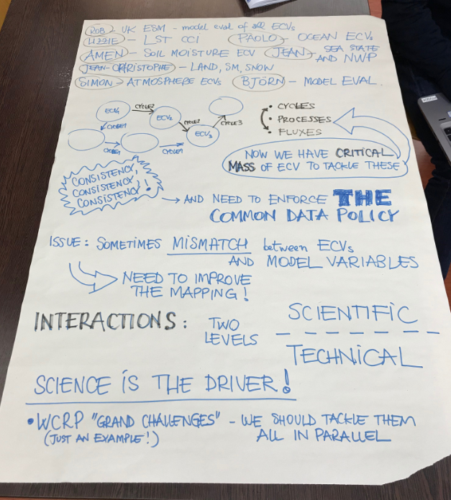

Figure 6. Group 3 discussion. One of the group’s discussions documented during the session. The names and associated ECVs of the people in the group are written at the top.

5. Output from Science Leads Session
The Science Leads discussion session took place parallel to the CSWG session. The following points were discussed:
- User requirements for KE
- Objectives for CCI+ follow-on
- CCI response to GCOS
- Addressing the reviews on the Consistency Paper
- CCI ECV teams and CMUG interactions

Objectives for CCI+ follow-on
- Documented in the EO Foresight Report (this needs to be sent to all Science Leads)
- Gap Analysis- areas of the CCI activities are not represented:
  - Look more at systems rather than individual ECVs
  - Should be more climate information based rather than just climate modelling
  - Could upcoming GCOS papers be used for cycles?
- Global Stocktake Report:
  - SLs could play a role in the top-down process from a global perspective to discern what’s declared from what’s needed.
  - Some countries lacking capacity to use EO data to help build their inventories; need to know what ECVs are needed for certain aspects of inventories.
- Foundation of the programme is R&D:
  - New sensors are introduced (new Sentinels)
  - New algorithms which are challenging the old ones used at the start of CCI
  - Reducing the error bars on the stocktake
  - Some ECV products still to do
  - Harmonisation across products still to do
- ACTIONS
  - Collate what has been done for each project over the next few years and what is being done in C3S
  - Be aware of what upcoming satellites are being used and their potential for cross-ECV
  - Richard Jones will ask for more targeted responses on the EO Foresight Report.

CCI responses to GCOS
What is the overall aim?
- To provide updated input from CCI which can guide the discussions at panel meetings
- To provide the feedback to the next update of requirements
Approaches:
- Updated CCI Report to GCOS to feed into WGClimate ECV Inventory
- CCI User Requirements per ECV to a basis for discussion by the GCOS Panels
- These are User Requirements (rather than satellite or in situ)
Actions:
- Complete the Updated CCI Report
- Coordination to find out who are the ECV Stewards
- Individual CCI teams to contact respective ECV Stewards with the updated Requirements
- DG to coordinate what is required for the CCI teams as information to present to the ECV Stewards
- Contact Panel Chairs to ensure ECV Stewards represent these view
Timeline:
- Requirements to ECV Stewards by end-December 2019
- Open review Jan-Feb 2020
- Panel meetings Mar 2020

How to further enhance the interaction between CMUG and CCI+ activities?
- Communication
  - Consolidate a list of all CRG activities per project for CMUG
  - Table of what CMUG is planning to do with all the data
  - CMUG representative to be invited to meetings/telecons of project CRGs
  - Modellers and observations need to work together more closely
  - Use the CCI datasets to add value to maximising tasks such as e.g. characterising uncertainties.
  - Slack- continue to use this and make a concerted effort to adopt it

- Discussion points for next CMUG integration meeting
  - Lightning talks to introduce posters and more time to discuss posters in coffee breaks
  - More thematic breakout groups which bring CCI and CMUG teams together.

- CCI meetings
  - Combine the CMUG and colocation meetings into a larger General Assembly which would save time and reduce carbon footprint.
  - Make remote access a possibility for streaming the presentations and discussions so break-out groups can involve virtual attendees

Annex 1: Programme
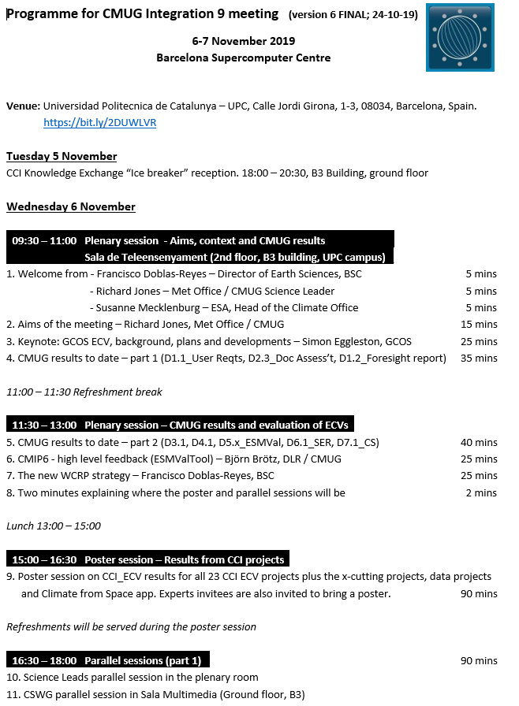

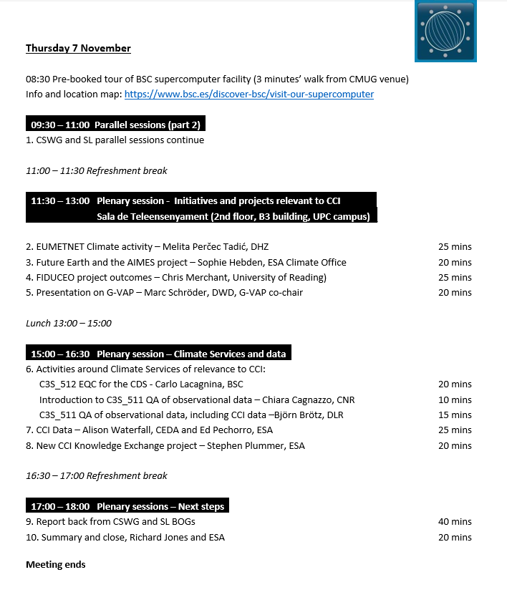

Annex 2: Presentations
Are available online at: https://drive.google.com/drive/folders/1EwpxZ7x4vsPzEVAJxDUcW6ETjmWS4W67

Annex 3: Registered Attendees
Total attendees: 59

1. CMUG:
Richard Jones (UK Met Office),
Kate Salmon, (UK Met Office)
Jean-Christophe Calvet (MétéoFrance / CNRS)
Frederique Cheruy (IPSL)
Yanfeng Zhao (IPSL)
Bjoern Broetz (DLR)
Pablo Ortega (BSC)
Ulrika Willen (SMHI)

2. ESA:
Marcus Engdahl
Frank Martin Seifert
Simon Pinnock
Sophie Hebden
Susanne Mecklenberg
Stephen Plummer
Paul Fisher
Anna Maria Trofaier
Marcus Engdahl
Ed Pechorro
Jérôme Benveniste
Paolo Cipollini

3. New CCI projects:
CCI | Science Lead | Other
Water Vapour | Michaela Hegglin | Marc Schröder,  Ye Hao
Sea Salinity | Nicolas Reul | Rafael Catany,  Frederic Rouffi  Paulo Cipollini
Sea State |  | Guillaume Dodet  Jean Bidlot
Lakes |  | Claudia Giardino,  Chris Merchant,  Monica Pinardi
Snow | Thomas Nagler
Permafrost | Annett Bartsch | Chloé Barboux
LST | Darren Ghent | Lizzie Good
HRLC | Lorenzo Bruzzone,  Francesca Bovolo | Cristina Domingo,  Lluis Pesquer

4. Existing CCI projects:
CCI | Science Lead | Other
Fire |  | Lucrecia Pettinari
Landcover |  | Celine Lamarche
SM |  | Amen Al-Yaari
Glaciers | Frank Paul
IS – Greenland |  | Louise Sandberg Sørensen
IS – Antarctica | Andy Shepherd | Dana Floricioiu
SI | Thomas Lavergne
Sea Level |  | Jean-François Legais
SST | Chris Merchant
Ocean Colour |  | Carsten Brockmann
Aerosol | Thomas Popp | Stefan Kinne
Ozone |  | Anne de Rudder
Clouds |  | Ulrika Willen
GHG | Michael Buchwitz | Frederic Chevallier
X-cutting, Data, Visualisation |  | Alison Waterfall,  Philip Eales.

5. Experts

Melita Perčec Tadić – EUMETNET
Rob Parker – Uni Leicester / UKESM / GHG_cci
Carlo Lacagnina – BSC for C3S_512
Joaquin Munoz Sabater – ECMWF for C3S
Caterina Tassone – WMO / GCOS
Cristina Gonzalez Haro – ICM CSIC
Chiara Cagnazzo – CNR for C3S_511
Rene Preusker – Freie Universität Berlin, WV_cci
Gilles Larnicol – C3S/BSC
Turiel Antionio - CSIC

Annex 4: Feedback from Integration Meeting
In order to improve the Integration Meeting for future years, a feedback form was circulated to the participants which received 24 responses.

The curated responses are shown below (responses were grouped into the most salient points). Full responses are available here: https://drive.google.com/file/d/1Xxe2yJlJ0gGa9PEjAKK_TC40Erc_Yc0b/view?usp=sharing. All responses collected were anonymous.

- What were your expectations of the CMUG Integration Meeting? (22 responses)

- To catch-up with CMUG progress and plans with respect to various ECVs/CCI projects
- To determine the uptake of CCI data within CMUG (and progress in the use of ECVs for climate modelling)
- Networking with Science Leads
- Networking/knowledge exchange between modelling and observation communities
- Networking/knowledge exchange between different ECV CCI projects (e.g. on common issues across ECVs)
- Gather feedback from climate modellers on the use of various ECVs
- Maximise the uptake of CCI data by the modelling community
- To identify the opportunities for integrating climate services in CCI activities.

- Overall, how well did the Integration Meeting fulfil your expectations?
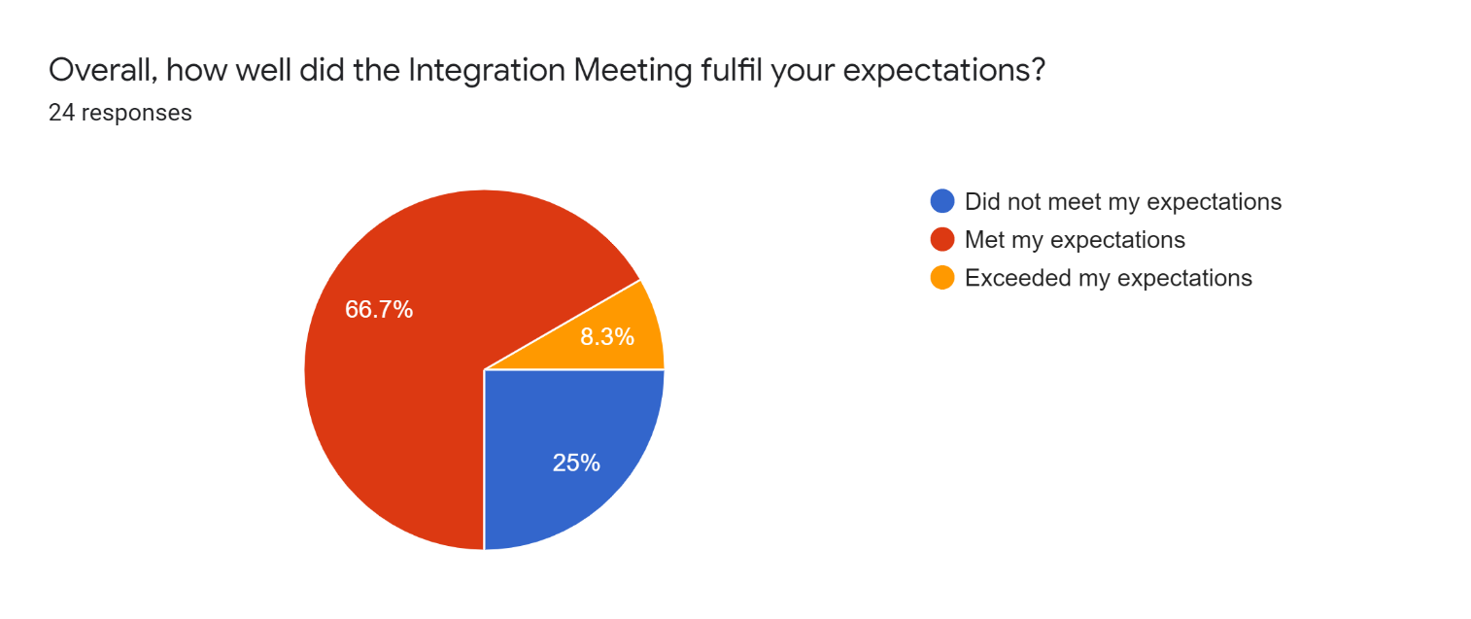
- What could we improve in the overall running of the workshop to better meet your expectations? (24 responses)

- Poster sessions and games to break down barriers were a good idea.
- Remote access to meetings could be improved to include outside participation
- Reduce the number of oral presentations and increase active participation (through more breakout groups and discussion sessions), to get e.g. the modelling, observations, CMUG communities talking to each other.
- Allow more time for individual exchanges and offline discussions (could be done through more time for poster sessions).
- Circulate talk and poster abstracts before the meeting and have a visual overview of which ECVs were represented at the meeting.
- Better introduction to all meeting participants by identifying who is who e.g. ‘data producer’, ‘climate scientist’ etc.
- In discussion sessions, better integration with CMUG to provide opportunity for feedback, iteration etc. and in order to ascertain requirements and data needs.
- More discussion on the ES science through explicit targeting on the cycles e.g. energy, water, carbon in order to identify gaps and co-design future work
- Introduce CCI projects to their matched users in CMUG so all CCI projects know (by sight) who is using their data (this could be done in the Plenary presentations from each of the relevant CMUG representatives).

- How well did the content and delivery of the plenary sessions meet your expectations?
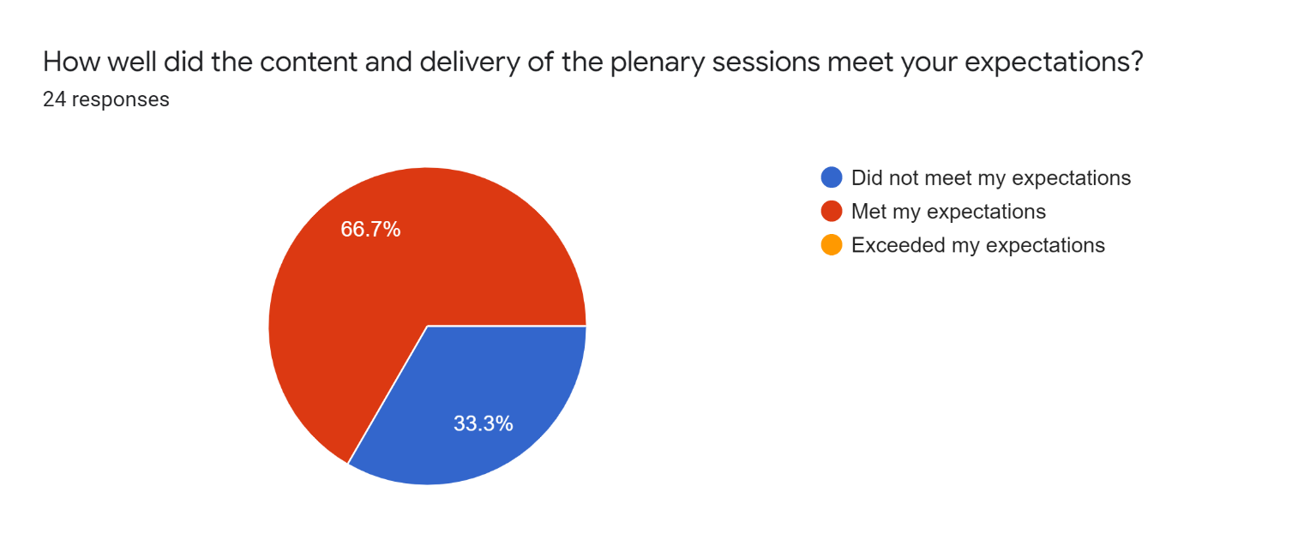

- How could we improve the plenary sessions to better meet your expectations? (20 responses)

- Reduce the number/time allocated to presentations in favour of division into sub-groups for more discussion sessions.
- Presentations were too long and dry with too much jargon. The content could be circulated ahead of the meeting as an info pack.
- Make the presentations more relevant to internal aspects (what we do, or should be doing)- and include programmatic aspects such as interactions with C3S, SAFs, GCOS, WRCP, as opposed to external aspects (what others do).
- Make the presentations more science related.
- Make sure the presentations cover the whole range of ECVs and not just a select few (this could be done through a series of flash talks on the 23 ECV’s project statuses by the Science Leads to give an overview as to how CMUG is working). This should include ample time for Q&A on each ECV.
- Plenary sessions should be used for engagement between CMUG and projects (this could be done through updates on science from CMUG members, which would then be further advanced through discussions in plenary). Suggestion e.g. 15 minutes per experiment from the relevant CMUG member?
- Discussions from the plenary session to be written (collaboratively) into an actionable protocol

- If applicable, how useful did you find the Climate Science Working Group discussion sessions? (13 responses)
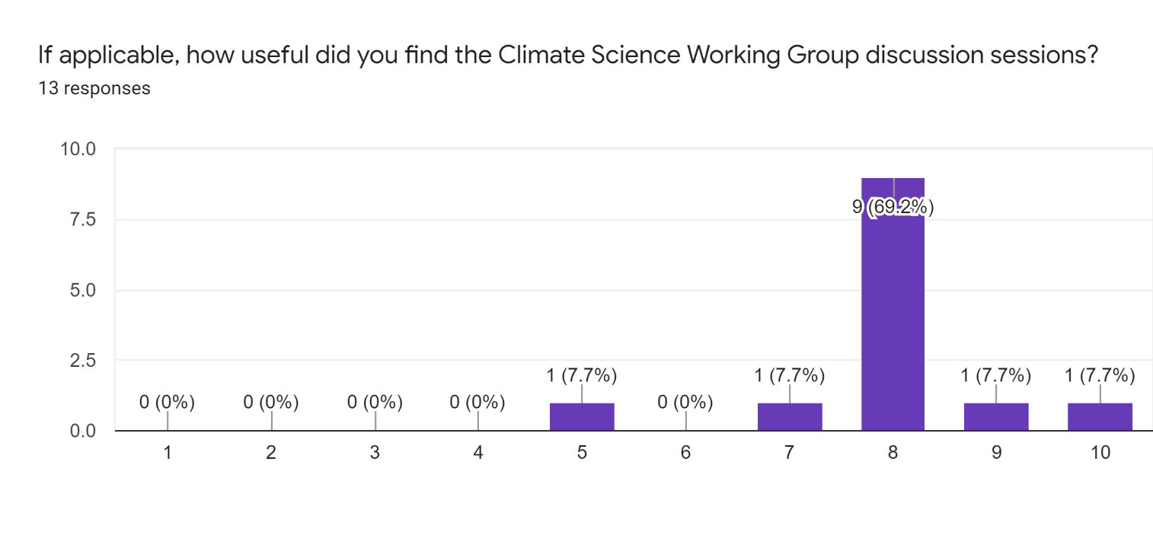
- If applicable, what could we do to better improve the running of the Climate Science Working Group discussion session? (12 responses)

- Playful and gaming aspects help break barriers
- Objectives should be made more clear with tangible outcomes from the session. These could be written into a short protocol.
- More time for discussion
- More potential for cross-over groups during discussion
- More visibility from CMUG and the work they are doing. Should achieve a list of priorities that everyone has contributed to (Science Leads, ESA, CRG, CMUG etc) to give a better structured programme.

- If applicable, how useful did you find the Science Lead discussion session?
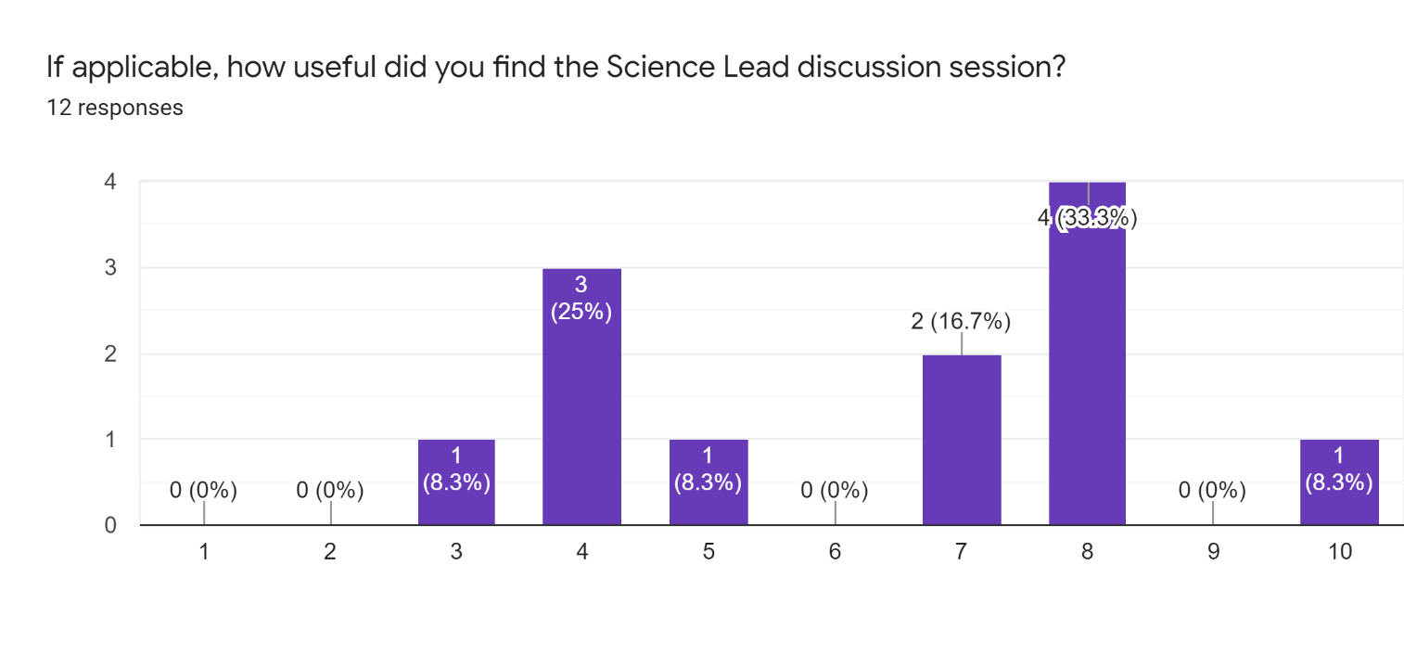
- If applicable, what could we do to better improve the running of the Science Lead discussion session? (6 responses)

- Clarify/introduce which people are involved in the Science Leads working group
- Sub-divide the Science Leads into climate process e.g. land, atmosphere, ocean to discuss topics in common
- Include the results of discussion into a list of actions (short, written protocol).
- Discussion of the consistency paper was not necessarily relevant to all Science Leads and the time could be better used.

- During the Integration Meeting, what did you find most helpful to you? (17 responses)

- The opportunity to network; with providers and scientists. Side discussions are extremely important (1-2-1 time between different ECV teams and climate scientists).
- Poster session is hugely popular for networking and discussion.
- Climate Science Working Group discussion.
- Science updates, ECV results talks/updates, uses of data and future plans presented in the plenary sessions.

- If you could change one thing about the Integration meeting, what would it be? (17 responses)

- Make the meeting more interactive (less plenary talks/oral presentations). Also, make more time in the programme for Q & A/discussion after the talks.
- Allow remote attendance at the Plenary Sessions
- Combine CMUG meeting with another CCI Meeting (e.g. Colocation) to make a General Assembly each year. This could be 3-4 days (with 1-2 overlapping days) which would allow more climate scientists to interact with more ECV scientists, and reduce CO₂ footprint.
- Instead of splitting the meeting into SL and CSWG, split into thematic science areas
- Better identification of CMUG representatives so that CCI leads can discuss requirements and expectations. Likewise, better identification of data providers to CMUG representatives so discussions may continue.

