Within ESA’s Climate Change Initiative (CCI), the Aerosol_cci+ project (3/2018 – 3/2022) aims at evolving and qualifying aerosol retrieval algorithms for the dual-view radiometer sensor line covering the periods 1995 – 2012 and 2016 – 2030 (ATSR-2 onboard ERS-2, AATSR onboard ENVISAT; SLSTR onboard SENTINEL-3A and SENTINEL-3B). Aerosol_cci+ builds on the legacy of a decade of Aerosol_cci(2) projects since 2010 in improving and benchmarking aerosol retrieval algorithms for climate applications. Updated algorithms from Aerosol_cci+ shall be used in future contracts of the Copernicus Climate Change Service to expand the length of aerosol Climate Data records with improved accuracy and information content. Within Aerosol_cci+ updated algorithms are used to process limited test data (typically one full global year per sensor): These datasets are then validated against ground-based AERONET sun photometer network measurements and inter-compared to other satellite aerosol datasets. Two user case studies will assess the potential and limitations of the improved datasets for climate services and re-analysis (data assimilation into a global atmospheric model) and for climate science applications (radiative forcing aerosol direct and indirect effects). Additionally, Aerosol_cci+ provides community support of the International Satellite Aerosol Science Network (AEROSAT) and its algorithm experiments.
The main output variables to be assessed are Aerosol Optical Depth (AOD) and Fine Mode AOD. The project works with two algorithms of different maturity: One mature algorithm from Aerosol_cci2 (by Swansea university) which provided the best combination of quality, uncertainty characterisation and size information will be further improved to overcome some of its core weaknesses (e.g. over bright surfaces) and to be applied consistently to the series of similar but slightly different dual view radiometers (while the two ATSR instruments are forward viewing, the SLSTR instruments are viewing rearward, which means sampling different parts of the aerosol scattering phase function with different sensitivities in the retrievals). A second innovative algorithm (by Rayference) with optimal estimation mathematical basis will be adapted from geostationary satellite observations to conduct combined retrievals of aerosol and thin clouds with full consideration of uncertainties and their correlations.
In the first year, Aerosol_cci+ has implemented several corrections to the mature algorithm and applied it to all four sensors (for the first time to SLSTR onboard SENTINEL-3B). The first Climate Research Data Package (CRDP – see Fig. 1) and associated light documentation (User Requirements Document, Algorithm Theoretical Baseline Document, End-to-end Uncertainty Budget, Product User Guide, System Specification Document, Product Validation Plan) are available for validation and initial user assessment in the next three months. The two user case studies will be set up in order to use the second CRDP which will become available in nine months. Aerosol_cci+ scientists contributed significantly to AEROSAT experiments on a multi-mission merged AOD record (Sogacheva, et al., 2020 – see Fig. 2) and on standards for AOD pixel-level uncertainty validation (Sayer, et al., 2020), which both led to peer-reviewed publications and large interest in the AEROCOM modelling user community. Aerosol_cci+ also led an all-CCI paper on multi-ECV consistency (Popp, et al., 2020 in review).
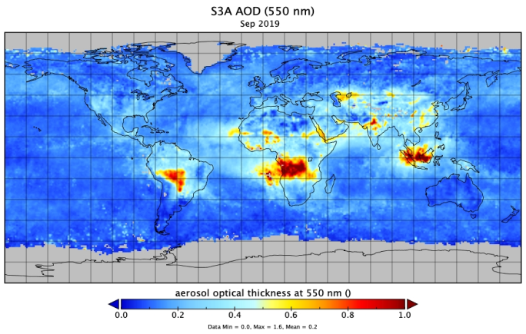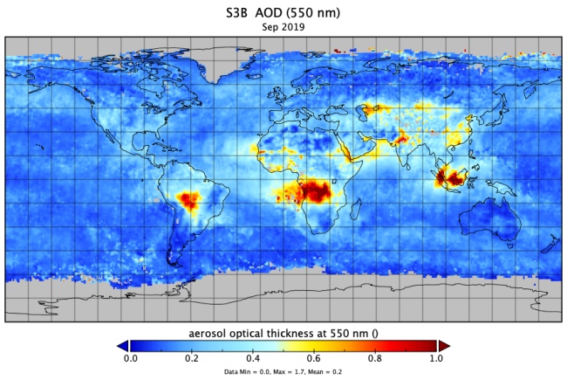
Figure 1: Aerosol_cci+ First Climate Research Data Package: Swansea algorithm AOD for September 2019 from SLSTR onboard SENTINEL-3A and SENTINEL-3B (from Aerosol_cci+ Algorithm Development Plan, v1.0, 2020)
Figure 2: Multi-mission merged AOD records for Europe and South-East China (from Sogacheva, et al., 2020)

Sogacheva Larisa, Thomas Popp, Andrew M. Sayer, Oleg Dubovik, Michael J. Garay, Andreas Heckel, N. Christina Hsu, Hiren Jethva, Ralph A. Kahn, Pekka Kolmonen, Miriam Kosmale, Gerrit de Leeuw, Robert C. Levy, Pavel Litvinov, Alexei Lyapustin, Peter North, Omar Torres and Antti Arola, Merging regional and global aerosol optical depth records from major available satellite products, Atmospheric Chemistry and Physics, 20, 2031 – 2056, https://doi.org/10.5194/acp-20-2031-2020, 2020
Sayer, A. M., Govaerts, Y., Kolmonen, P., Lipponen, A., Luffarelli, M., Mielonen, T., Patadia, F., Popp, T., Povey, A. C., Stebel, K., and Witek, M. L.: A review and framework for the evaluation of pixel-level uncertainty estimates in satellite aerosol remote sensing, Atmospheric Measurements and Techniques, 13, 373–404, https://doi.org/10.5194/amt-13-373-2020, 2020.
Popp Thomas, Michaela I. Hegglin, Rainer Hollmann, Fabrice Ardhuin, Annett Bartsch, Ana Bastos, Victoria Bennett, Jacqueline Boutin, Michael Buchwitz, Emilio Chuvieco, Philippe Ciais, Wouter Dorigo, Darren Ghent, Richard Jones, Thomas Lavergne, Christopher Merchant, Benoit Meyssignac, Frank Paul, Shaun Quegan, Tracy Scanlon, Marc Schröder, Stefan Simis, Ulrika Willén, Consistency of satellite climate data records for Earth system monitoring, Bulletin of the American Meteorological Society, in review, 2020
Schutgens, N., Sayer, A. M., Heckel, A., Hsu, C., Jethva, H., de Leeuw, G., Leonard, P. J. T., Levy, R. C., Lipponen, A., Lyapustin, A., North, P., Popp, T., Poulson, C., Sawyer, V., Sogacheva, L., Thomas, G., Torres, O., Wang, Y., Kinne, S., Schulz, M., and Stier, P.: An AeroCom/AeroSat study: Intercomparison of Satellite AOD Datasets for Aerosol Model Evaluation, Atmos. Chem. Phys. Discuss., https://doi.org/10.5194/acp-2019-1193, in review, 2020.
Gliß, J., Mortier, A., Schulz, M., Andrews, E., Balkanski, Y., Bauer, S. E., Benedictow, A. M. K., Bian, H., Checa-Garcia, R., Chin, M., Ginoux, P., Griesfeller, J. J., Heckel, A., Kipling, Z., Kirkevåg, A., Kokkola, H., Laj, P., Le Sager, P., Lund, M. T., Lund Myhre, C., Matsui, H., Myhre, G., Neubauer, D., van Noije, T., North, P., Olivié, D. J. L., Sogacheva, L., Takemura, T., Tsigaridis, K., and Tsyro, S. G.: Multi-model evaluation of aerosol optical properties in the AeroCom phase III Control experiment, using ground and space based columnar observations from AERONET, MODIS, AATSR and a merged satellite product as well as surface in-situ observations from GAW sites, Atmos. Chem. Phys. Discuss., https://doi.org/10.5194/acp-2019-1214, in review, 2020.

